Assignment - 4

Python Programming

|  |  |
| --- | --- |
| Assignment Date | 26 October 2022 |
| Student Name | Ms.Rithika VA |
| Student Roll Number | CITC1907035 |
| Maximum Marks | 2 Marks |

Problem Statement: Customer Segmentation Analysis

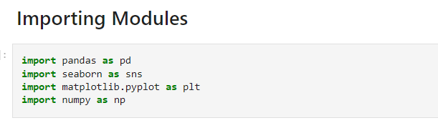

1. Download the dataset
2. Look the dataset into the tool

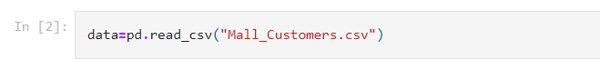

1. Perform Below Visualizations

∙ Univariate Analysis

∙ Bi-Variate Analysis

∙ Multi-Variate Analysis

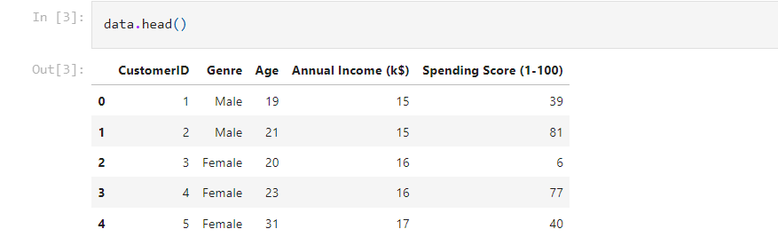



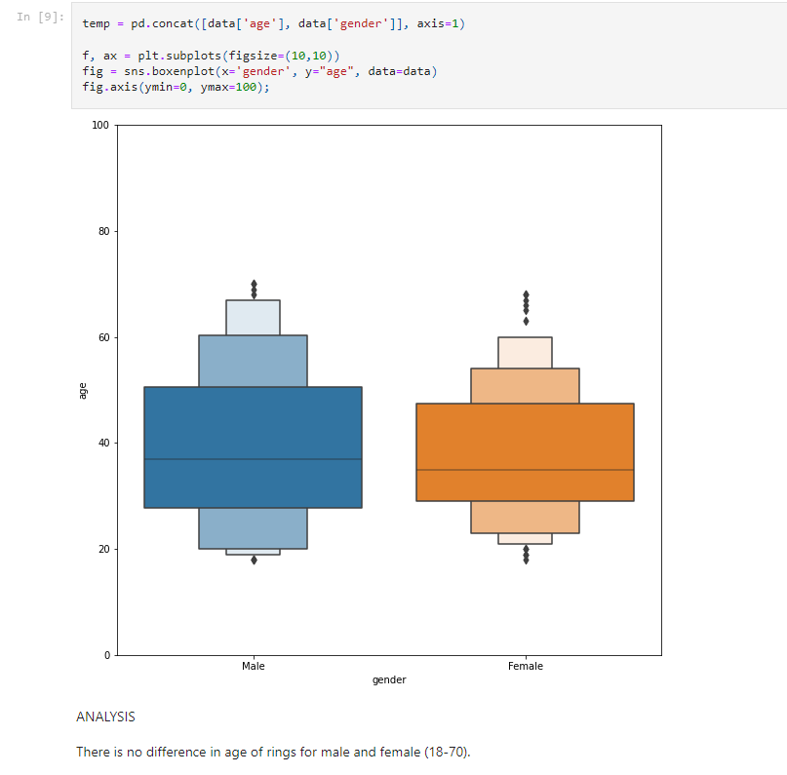

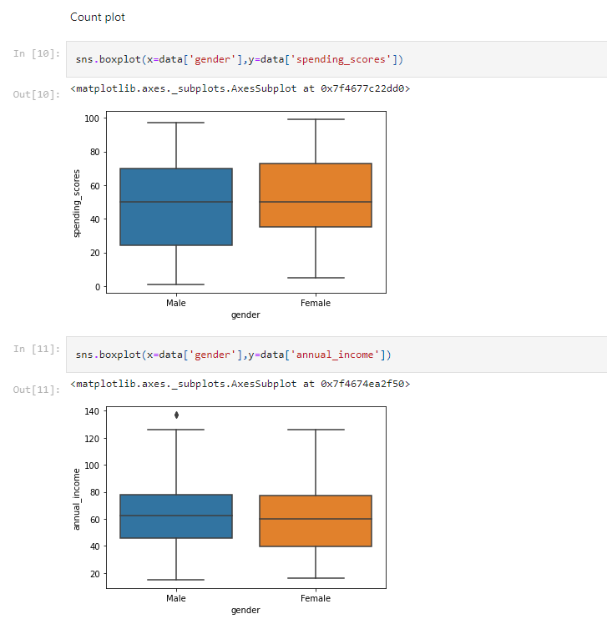

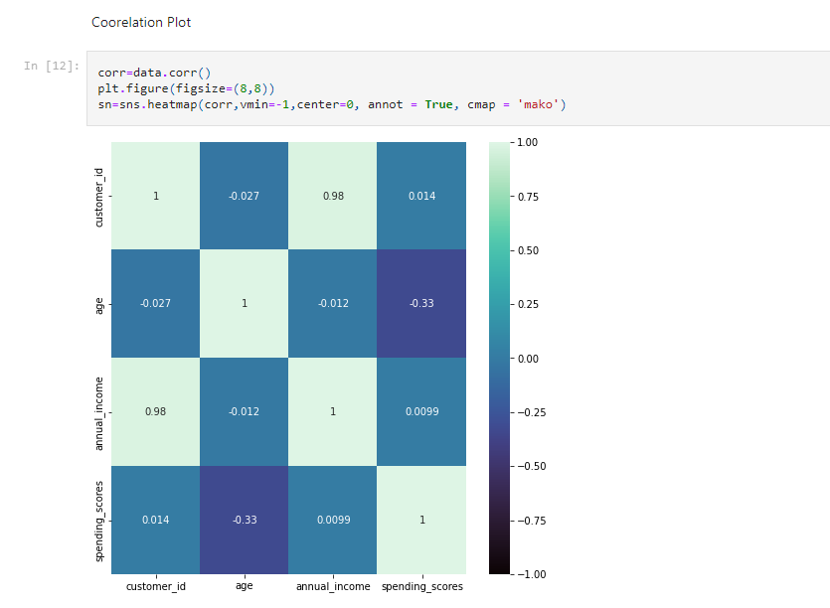

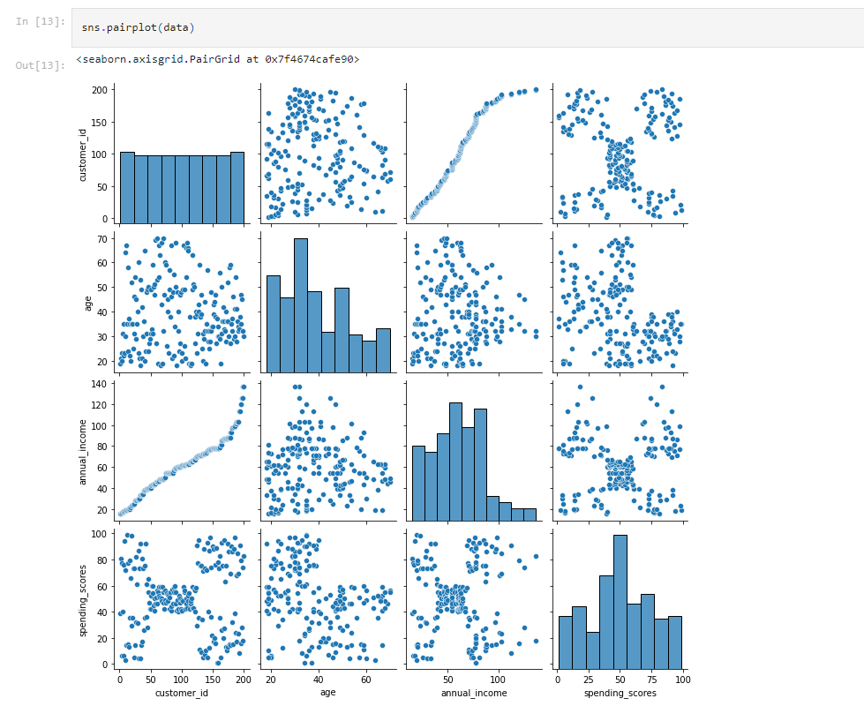

1. Perform descriptive statistics on the dataset.

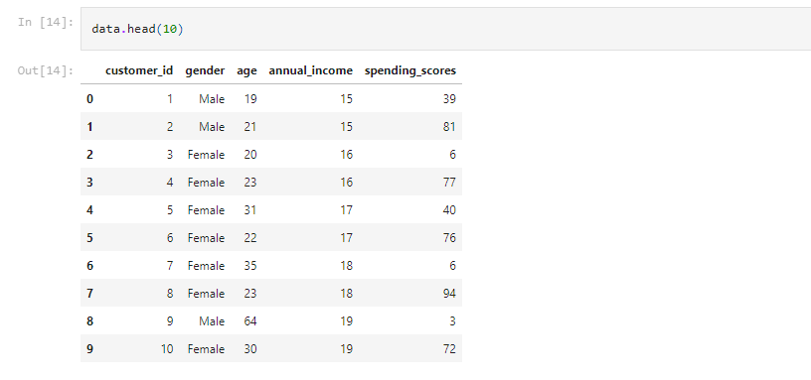

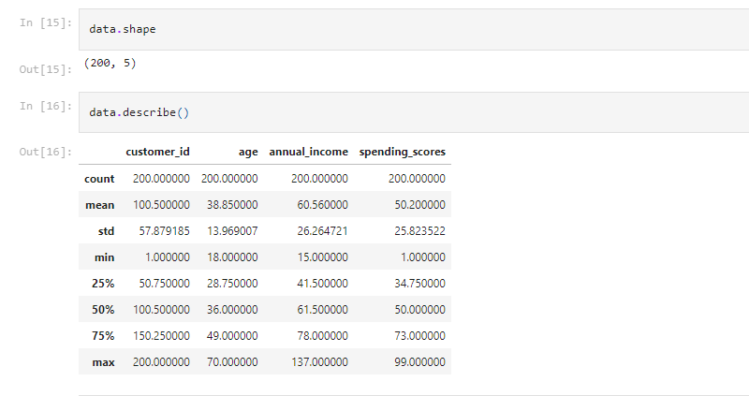

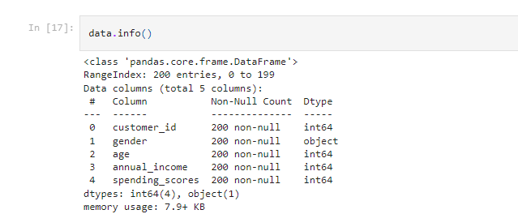

1. Check for Missing values and deal with them

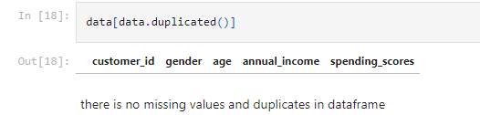

1. Find the outliers and replace them

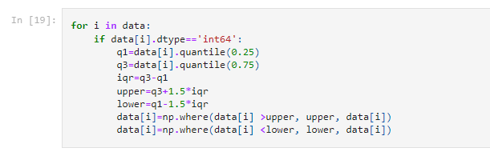

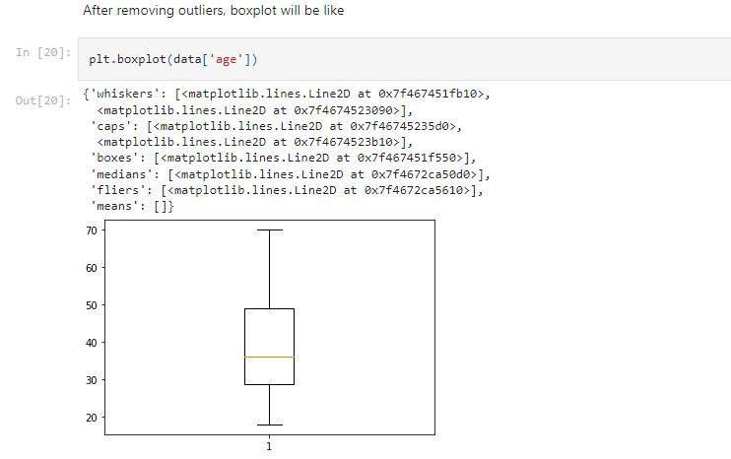

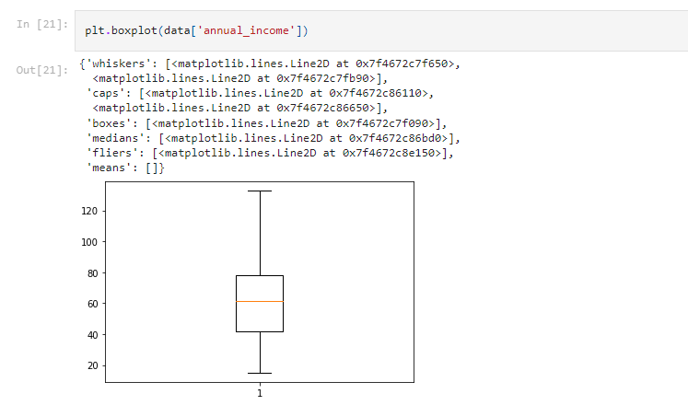

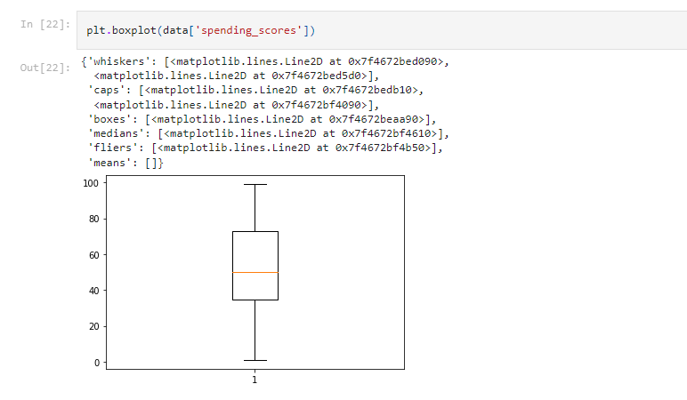

1. Check for categorical columns and perform encoding

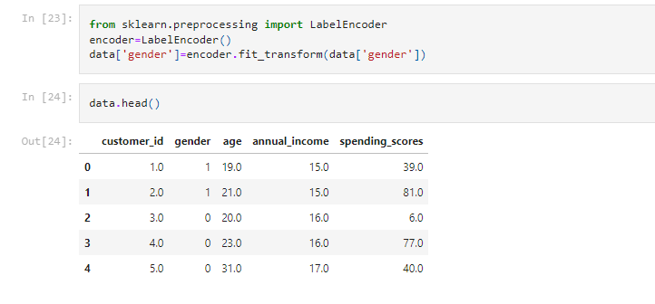

1. Scaling the data

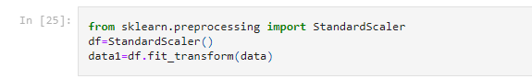

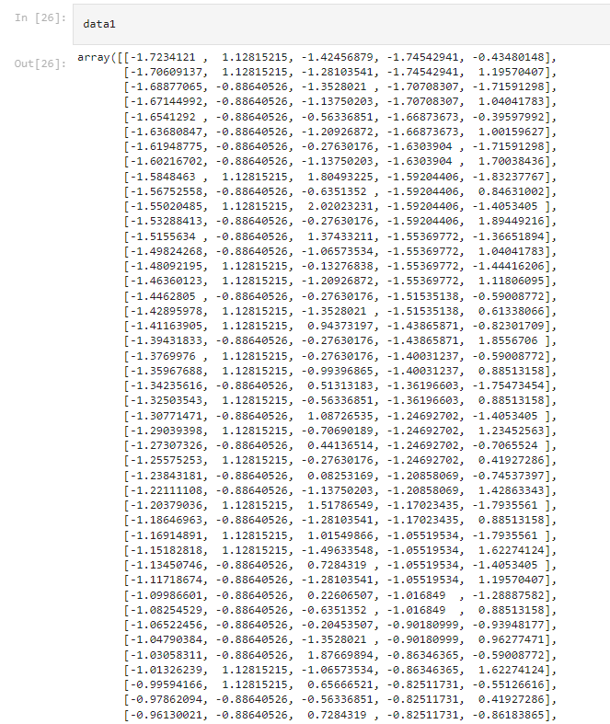

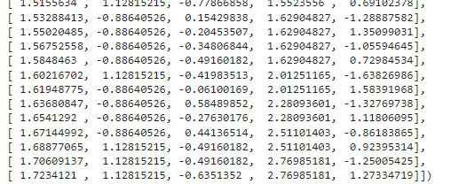

1. Perform any of the clustering algorithms

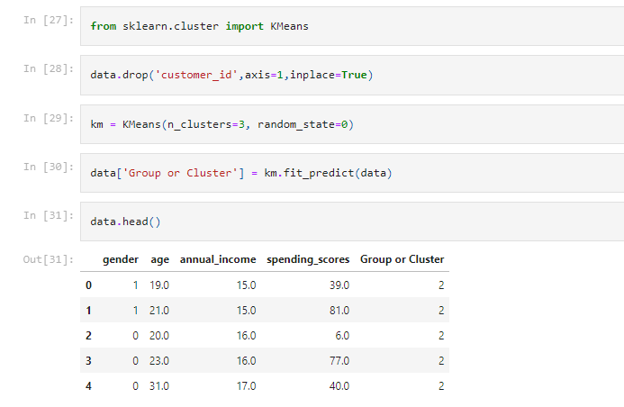

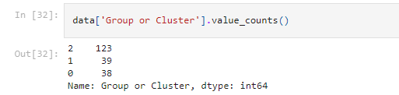

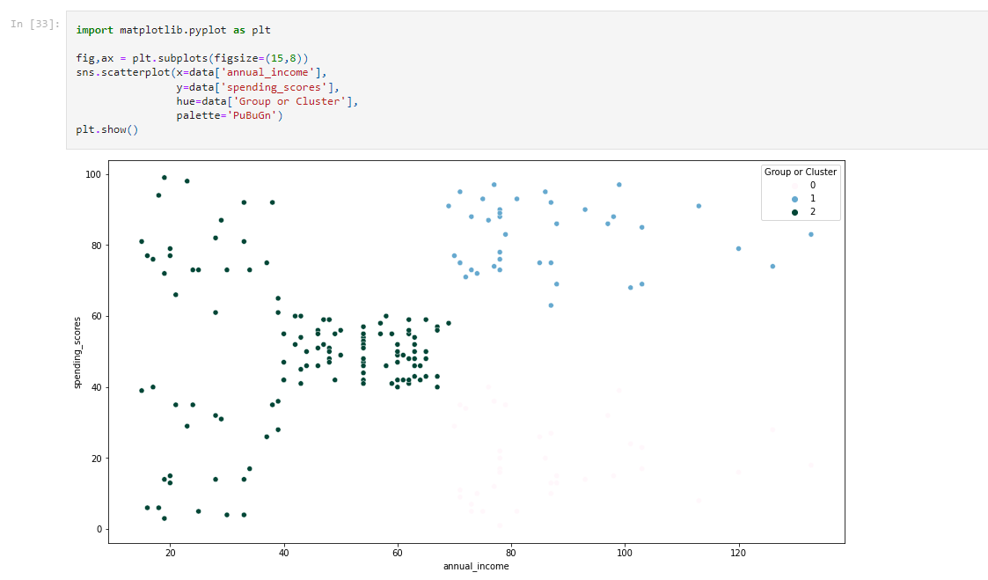

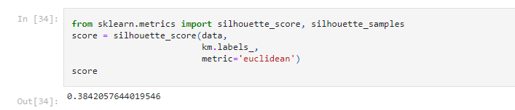

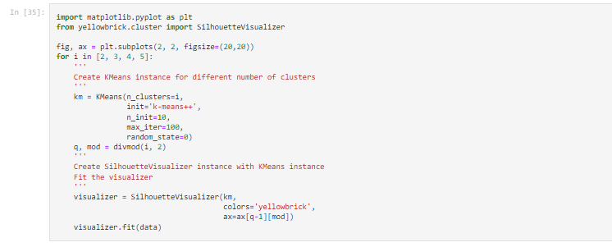

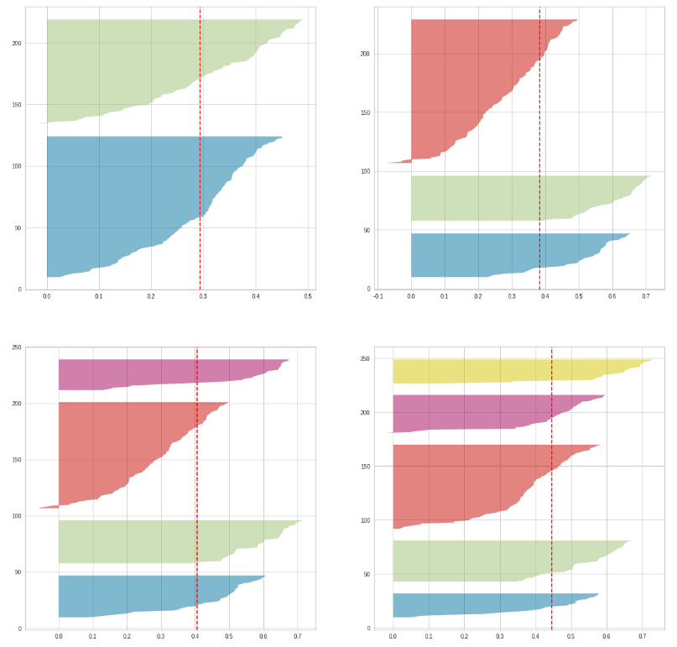

1. Add the cluster to the primary dataset

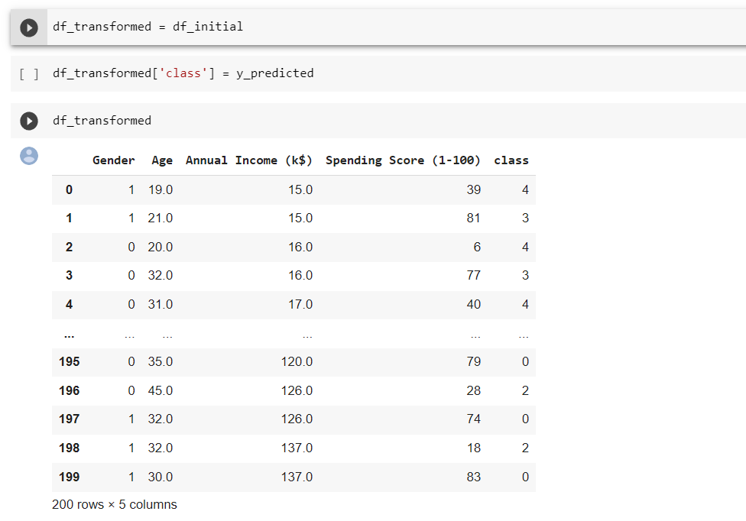

1. Split Dataset into Predictors and Target

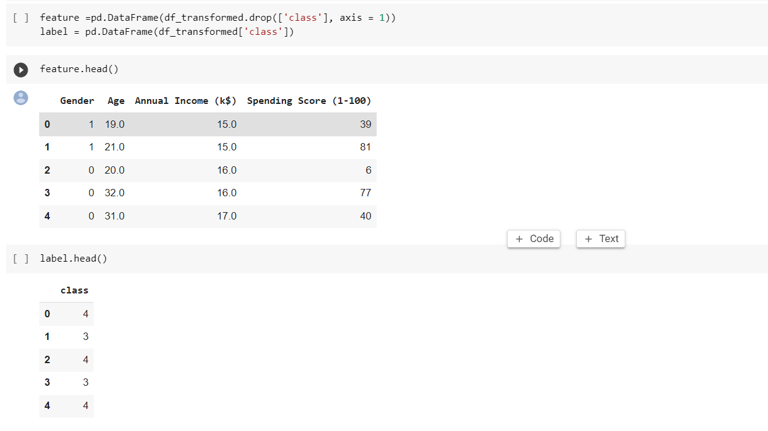

1. Splitting into Training and Test Datasets

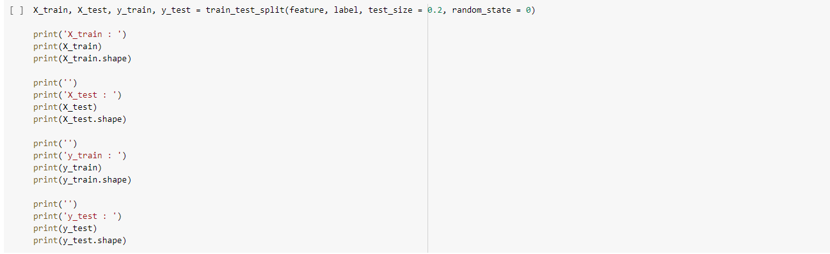

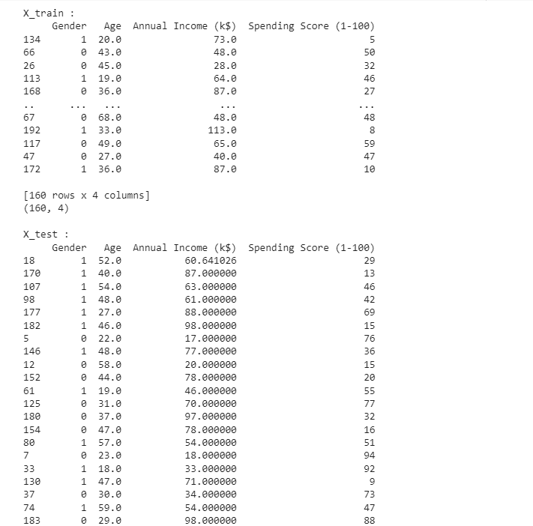

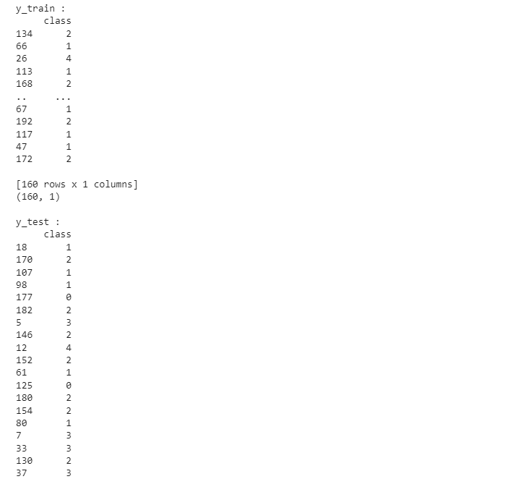

1. Build the Model

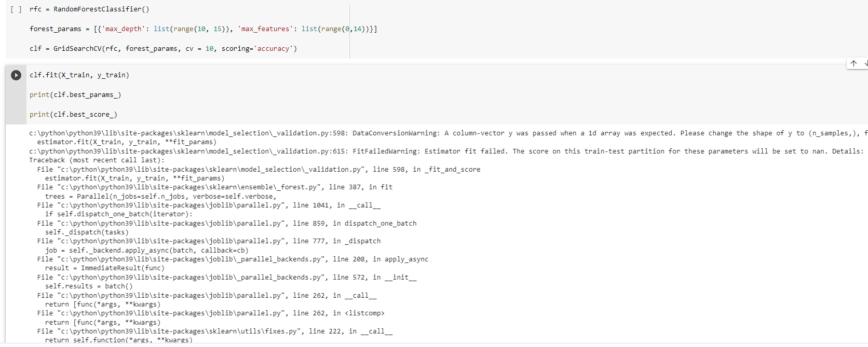

1. Train the Model



1. Test the Model

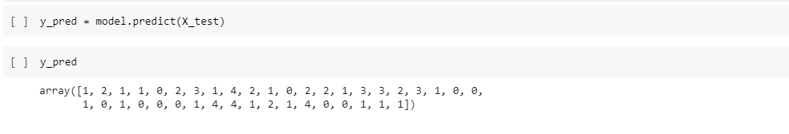

1. Evaluation Metrics

